AGM Notice

We warmly invite you to the Annual General Meeting (AGM) of Medway Asthma Self Help at 7.00pm on Thursday 30th November 2023. This year’s meeting will take place at our MASH Centre, 131 Watling Street, Gillingham.

Annual General Meeting (please see AGM agenda enclosed)
In this meeting, after accepting last year’s minutes, you will be able to hear reports from the Chair of Trustees, the Treasurer and MASH’s asthma nurse. There will also be the election of trustees and auditors of 2023-2024 and a guest speaker.

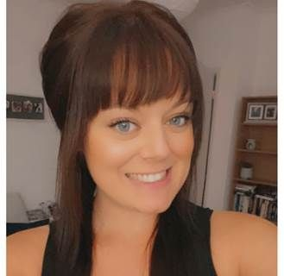
Guest Speaker – Samantha Whybrow
Samantha is a great supporter of the work we do here
at MASH. She has been a paediatric nurse since 2016
and has recently become the clinical lead for asthma across
Medway and Swale. Samantha is also going through the
process of becoming a MASH Trustee.

Trustees

We are seeking new trustees to expand and strengthen our team: could this be you? We are looking to expand the board with a range of skill and experience, including (but not limited to): people with asthma, people who care for or work with people with asthma; people with human resources, accountancy and media experience. Please let us know if you would like to know more with what is involved.

Trustees are a legal requirement of a charity and we cannot function without them. Our trustees currently attend evening meetings for approximately one hour on the first Wednesday of each month. Trustees have overall control of the charity and are responsible for making sure it is doing what it was set up to do, and that the charity’s resources are used responsibly.

If you would like to stand for election or would like to nominate someone else (with their consent) please give details on the reply form or contact us via telephone, email or via the website (link below). Anyone wishing to stand for election has to be proposed and seconded by two different people.

Reply form
Please complete and return the reply form to Medway Asthma Self Help, 131 Watling Street, Gillingham, ME7 2YY by Monday 20th November 2023. Alternatively you can email your reply to admin@medwayasthmaselfhelp.co.uk, telephone 01634 855844 or visit our website http://www.medwayasthmaselfhelp.co.uk/agm

Best Wishes

Clive Johnson Peter Burt
Chair Vice-Chair

